My website(only have mobile)

github page :[https://euler456.github.io/509AT1/](https://euler456.github.io/509AT1/#/)

My repositories:<https://github.com/euler456/509AT1.git>

1. Functionality demonstrated to teacher on a mobile phone

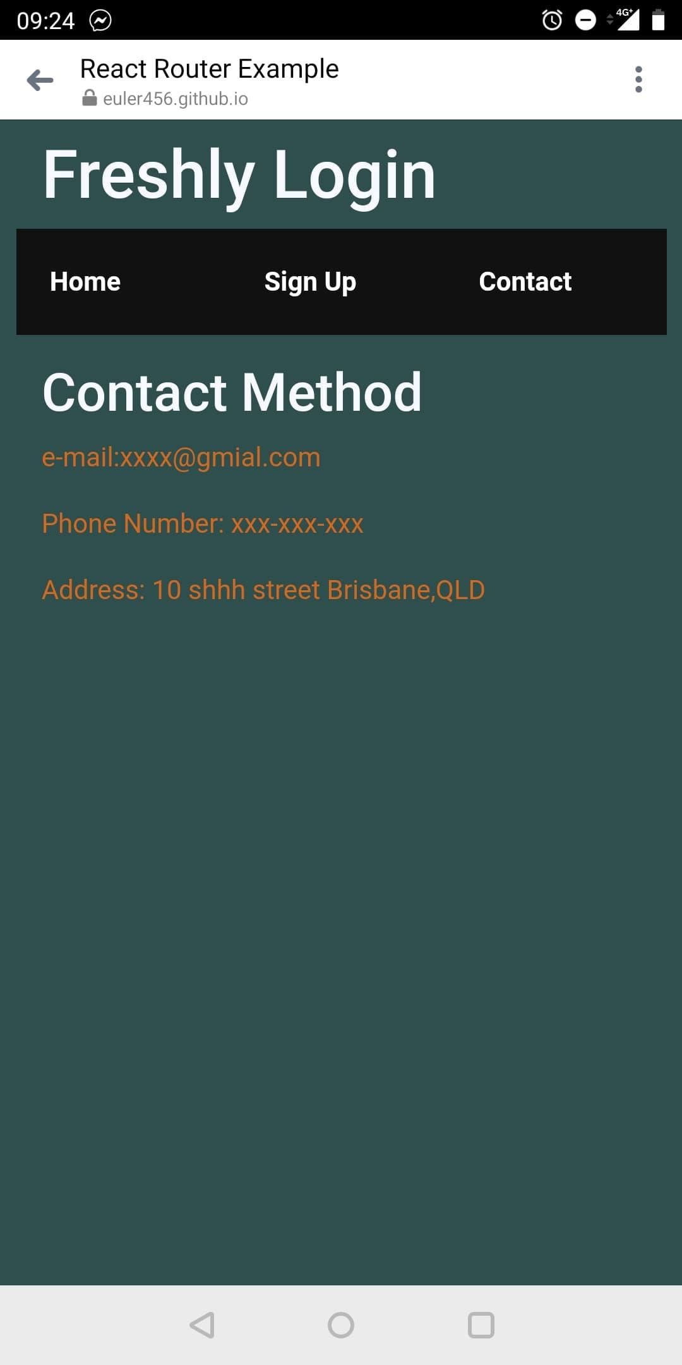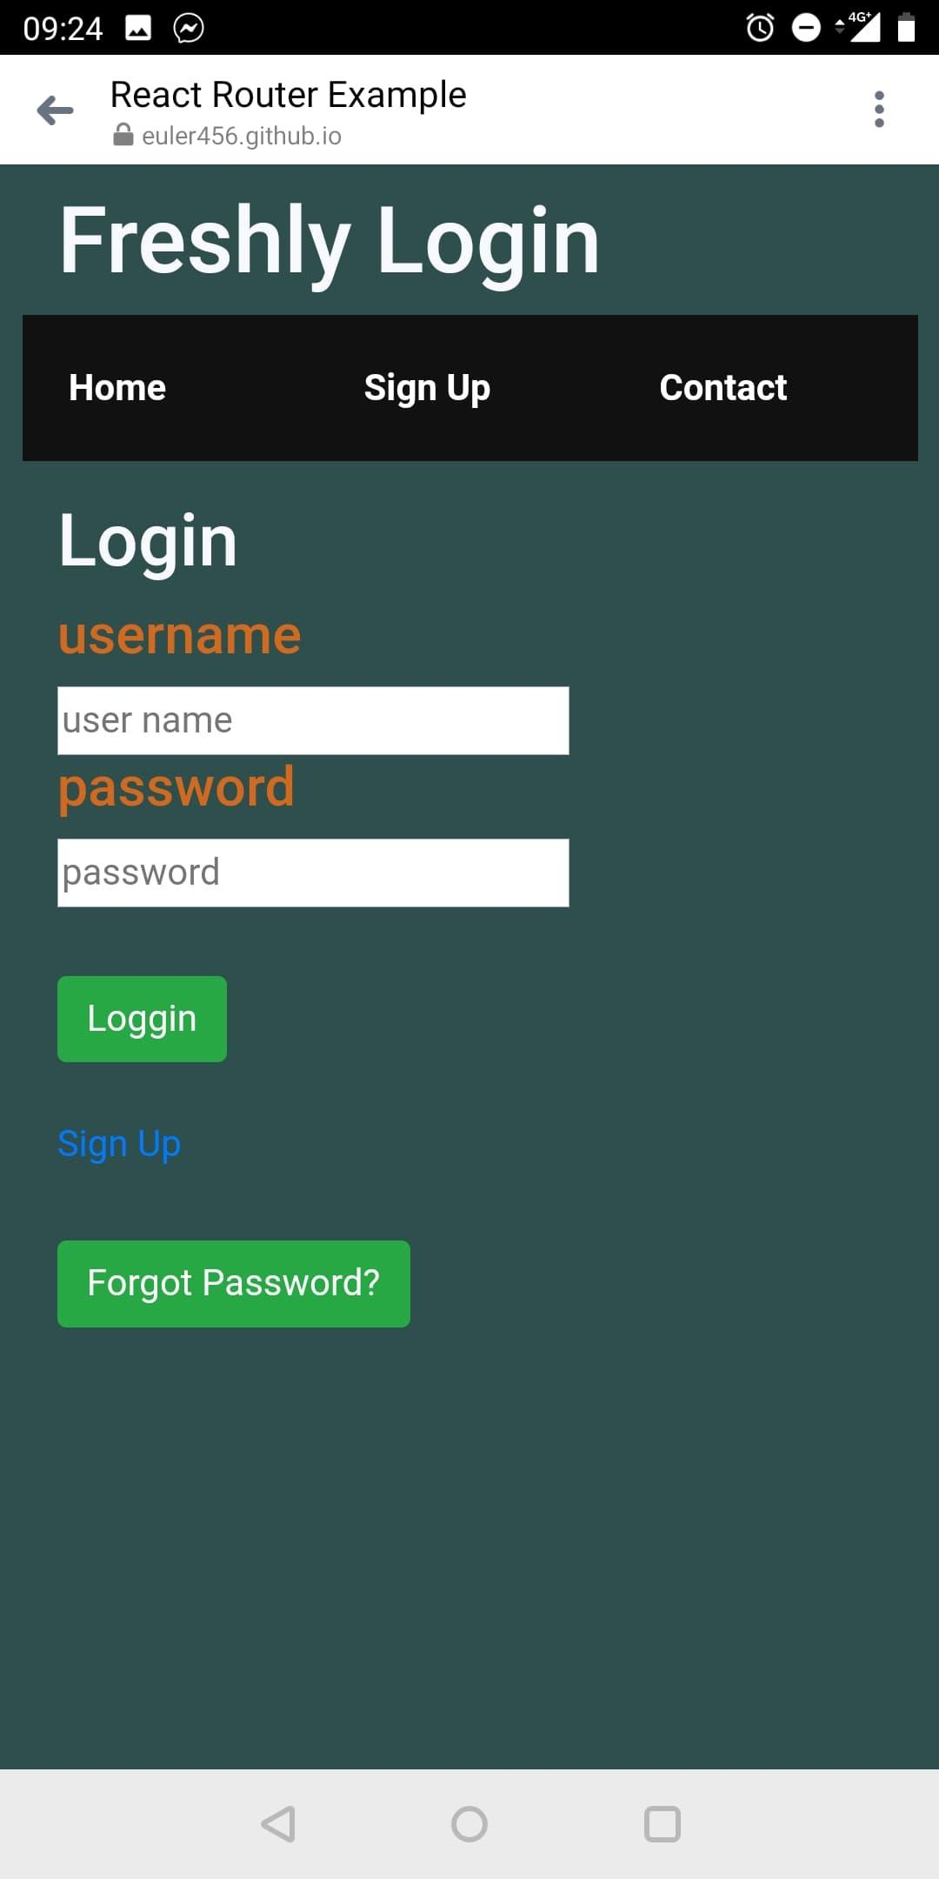

1. Describe the scope of the project that this prototype relates to

Including one html page and two files(js,css),and the user can use the panel to switch between 3 pages. Also the website requests login /sign up input form,and a non-working web form.

1. Describe why prototyping tool chosen was the best for the outlined task

It is easy to manage the code ,and prototyping tools can connect some third parties open-sources codes.

1. Write three paragraphs each for how you think the tool has handled the rendering of all CSS/HTML and JavaScript code

React index.js file uses ReactDOM.render() function to get the id from the index.html, and it through the React.Component() function to separate the html content. The developer can through this function return the html part they want to.

Bootstrap function can simplify css code.I use bootstrap grid-function to control the website panel. Grids function can cut the panel in several pieces.

I use github page to upload my mobile website page. Github page can show the website which you upload your code in the github repository.

1. Conclusion as to how you might be able to use some of the components the tool has rendered going forward to UX2

I will use this website which I created in UX1 for my UI appearance. Furthermore, I am going to build the localStorage and Fetch API to satisfy the request of UX2.

1. Document the licensing and/or costs associated with your chosen tool

Github page:4dollars/per month